AUTOMATED TEST EXECUTION & REPORTING FRAMEWORK
Project Flow & Scope Document

- Project Title:
Automated Test Execution & Reporting Framework for BCM Door Lock Function.
- Project Description:
- This project is a basic automotive automation framework built using Python
- It simulates the functionality of a Body Control Module (BCM) for door lock and unlock operations
- The primary objective of the project is to validate the door lock feature within the BCM ECU by automating the execution of predefined test cases
- These test cases are maintained and managed in an Excel file
Python automatically reads the test cases, executes the defined logic, compares the expected and actual results, and generates the following outputs:
- Log file
- Report file
- Pie chart analysis

- Objectives:
- To automate BCM Door Lock testing
- To read test cases from Excel
- To generate automatic test reports
- To create log files for execution tracking
- To display graphical analysis using charts

- Project Members:
- Hande Omkar
- Gusain Shubham
- Mohamed Ijaz

- Tools & Technologies:
- Python – Programming
- Pandas – Reading Excel file
- OpenPyXL – Excel support
- Matplotlib – Pie chart generation

- Software Requirements:
- Python 3.x
- VS Code
- Excel

- Flowchart:
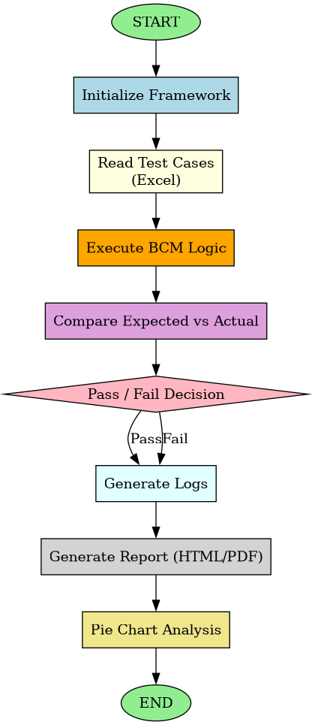
- Future Enhancement:
- Integration with CAN tools (Vector CANoe)
- Real ECU communication
- Dashboard-based reporting
- Advanced analytics

- Conclusion:
- The Automated Test Execution & Reporting Framework for BCM Door Lock Function successfully demonstrates the use of Python to automate functional testing in an automotive context.
- The framework automates testing by running test cases, checking results, and creating logs and reports with charts.
- The use of Excel for test case management and automated report generation makes the framework user-friendly and easy to maintain.

